
National Statistical Committee of the Kyrgyz Republic

Express information
July 10, 2024

Main indicators of the socio-economic development of the Kyrgyz Republic
in January-June 2024
(million soms)
 | Actual | January- June  2024  in % to January- June  2023 | Reference: January- June  2023¹ in % to January- June  2022
Gross domestic product²  (preliminary estimation) | 559 723,7 | 108,1 | 102,2
excluding Kumtor mining enterprise | 527 085,8 | 109,9 | 104,0
Volume of industrial products  (works, services) - total | 237 456,0 | 101,0³ | 100,1³
excluding Kumtor mining enterprise | 161 389,3 | 110,9³ | 110,7³
Mining | 27 827,9 | 96,3³ | 106,6³
Manufacturing | 176 273,1 | 100,1³ | 97,5³
of which production of food products (including beverages) and tobacco products | 37 246,3 | 117,9³ | 109,1³
Provision (supply) of electricity, gas, steam and conditioned air | 30 784,3 | 109,0³ | 109,7³
Water supply, purification, waste treatment and recovery of secondary raw materials | 2 570,7 | 121,4³ | 95,3³
Gross output of agriculture, forestry  and fishery | 107 827,5 | 103,3 | 102,7
Fixed assets investment (capital investment) from all sources of funding | 76 745,3 | 154,7 | 110,2
Gross construction output | 76 279,5 | 148,5 | 111,1
Total volume of wholesale and retail trade, repairs of vehicles and motorcycles | 461 948,8 | 121,0 | 107,4
of which retail trade except trade  of vehicles and motorcycles | 197 230,3 | 115,9 | 105,5
Hotels and restaurants services | 14 394,3 | 123,4 | 122,9
The volume of freight by all modes  of transport, thsd. tons | 23 838,8 | 106,8 | 114,7
Passengers carried by all modes  of transport, million people | 264,5 | 107,5 | 108,4
Postal and courier services thsd. soms | 702,7 | 66,9 | 68,7
Communication services | 17 402,8 | 111,6 | 110,3
Consumer price index |  | 105,1 | 112,7
- by December 2023 | 102,4
- by June 2023 | 104,5
Number of registered unemployed, thousand people | 58,2 | 77,8 | 99,5
Average monthly nominal wage per employee⁴, soms | 34 710 | 111,1⁵ | 131,7⁶
Volume of foreign and mutual trade⁷, million US dollars | 6 488,8 | 118,6⁵ | 133,6⁶
of it the EAEU member states | 1 751,1 | 99,6 | 104,7
Export ⁷, million US dollars | 1 046,2 | 104,8⁵ | 136,2⁶
of it the EAEU member states | 406,9 | 75,7 | 116,8
Import ⁷, million US dollars | 5 442,6 | 121,7⁵ | 133,0⁶
of it the EAEU member states | 1 344,2 | 110,2 | 100,1
__________________________
¹ Certain indicators have been updated.
² The data are calculated in accordance with the international standard of the System of National Accounts 2008.
³ Physical volume index.
⁴ January-May 2024 (excluding small businesses).
⁵ January-May 2024 as a percentage of January- May 2023
⁶ January-May 2023 as a percentage of January- May 2022
⁷ January-May 2024

Changes in the main socio-economic indicators in
the Kyrgyz Republic

Gross domestic product  (as s percentage of the corresponding period of the previous year) | Industrial products  (as a percentage of the corresponding period of the previous year)

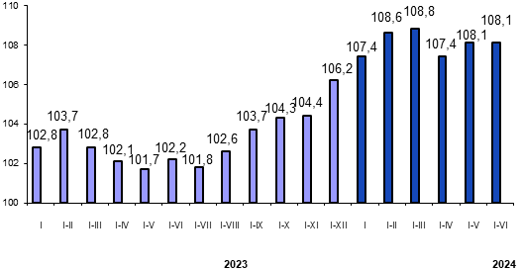 | 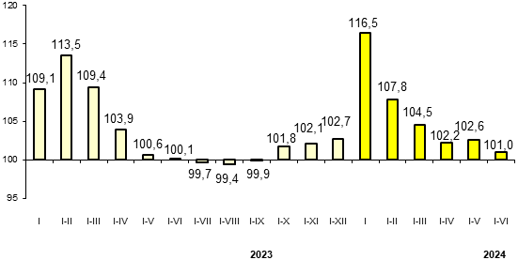

Gross agricultural output  (as a percentage of the corresponding period of the previous year) | Fixed capital investments  (as a percentage of the corresponding period of the previous year)

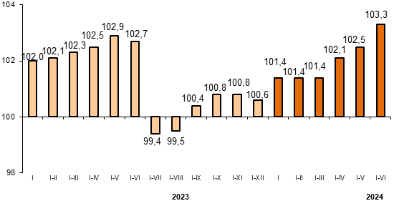 | 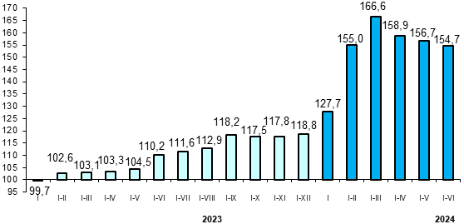

Consumer price index

(as a percentage of the corresponding period  previous year) | (as a percentage of December of the previous year)

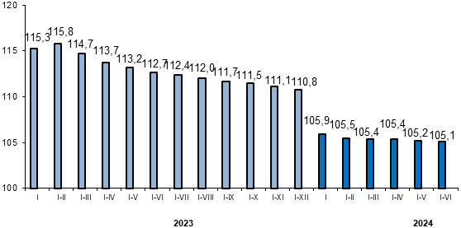 | 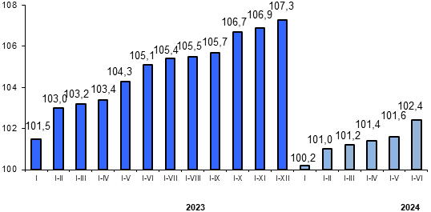

Average monthly nominal wages  (soms) | Real wages  (as a percentage of the corresponding period of the previous year)

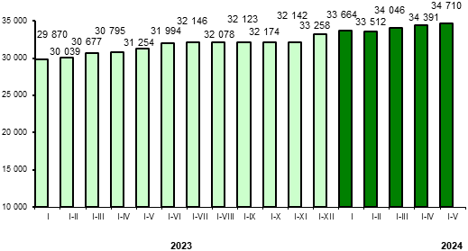 | 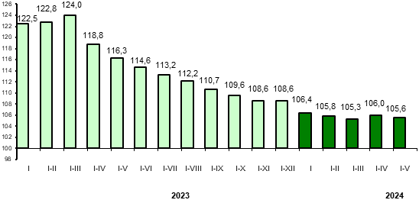

Import volume  (as a percentage of the corresponding period of the previous year) | Export volume  (as a percentage of the corresponding period of the previous year)

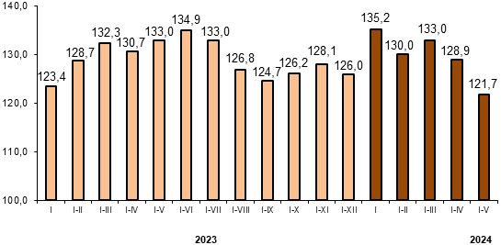 | 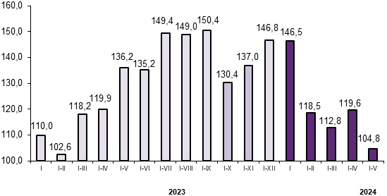

Import from the EAEU Member States  (as a percentage of the corresponding period of the previous year) | Export to the EAEU Member States  (as a percentage of the corresponding period of the previous year)

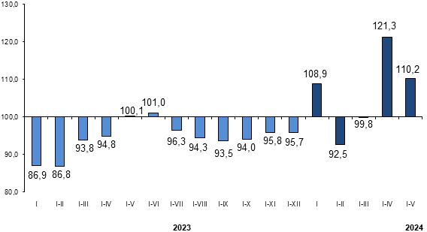 | 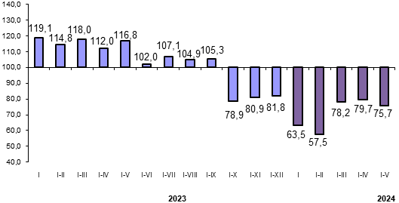

Retail and wholesale trade turnover
(as a percentage of the corresponding period of the previous year)

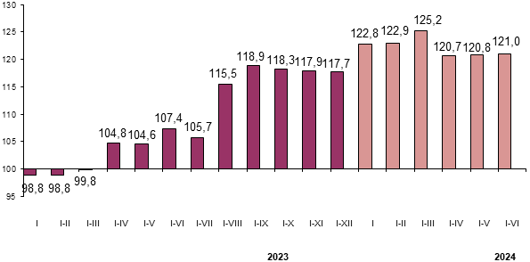

Chairman B.Zh. Kudaibergenov

